Preparation of Papers for Fully3D 2027 Submission
Abstract—Please insert your abstract here. This abstract can be slightly longer than the very short 150-word version required for the online submission system. Include a sentence about the novelty and impact to medical imaging.
First A. Author, Second B. Author, and Third C. Author

Index Terms—Enter three to five keywords or phrases in alphabetical order, separated by commas.

Introduction
Submission rules
- Submission must be in PDF format only.
- Use a two-column format (as in this template).
- The font size for the main text should be 11, while the abstract and references can use font size 9.
- Submission is limited to a maximum of 4 pages, including all content (strict limit).
- Additionally, prepare a short abstract (maximum 150 words) for entry into the online submission system. This abstract will be used for the program only and will not be part of the review process nor the final proceedings.
Replace this text with the introduction of your paper. State the problem addressed, summarize the relevant prior work [1], [2], and clearly describe the goal and the contribution of the work presented in this submission.
Define abbreviations and acronyms the first time they are used in the text, even if they have already been defined in the abstract. Use SI units throughout the paper.

Materials and Methods

Page Layout and Styles
This template uses A4 paper with a two-column body; the title and author names span both columns. Use the built-in styles of this document (e.g., “Text”, “heading 1”, “heading 2”, “References”) by typing over the example text. Author affiliations go in the unnumbered footnote at the bottom of the first column. Do not change the margins, font sizes, or line spacing to squeeze more text into the page limit.

Equations
Number equations consecutively with equation numbers in parentheses flush with the right margin, as in (1). Define all symbols before or immediately after the equation in which they appear. As an example, the MLEM update is
$x_{j}^{(n+1)}=\frac{x_{j}^{(n)}}{\sum_{i}{a_{ij}}}\sum_{i}{a_{ij}\frac{y_{i}}{\sum_{k}{a_{ik}x_{k}^{(n)}}}}$ (1)
where y_{i} denotes the measured data, a_{ij} the system matrix element, and x_{j}^{(n)} the image estimate at iteration n. Refer to “(1),” not “Eq. (1),” except at the beginning of a sentence.

Figures and Tables
Figures and tables should be one column wide or span the full page width, and must be readable when printed. Place figure captions below figures and table titles above tables. All figures and tables count toward the 4-page limit and must be cited in the text (e.g., Fig. 1 and Table I).
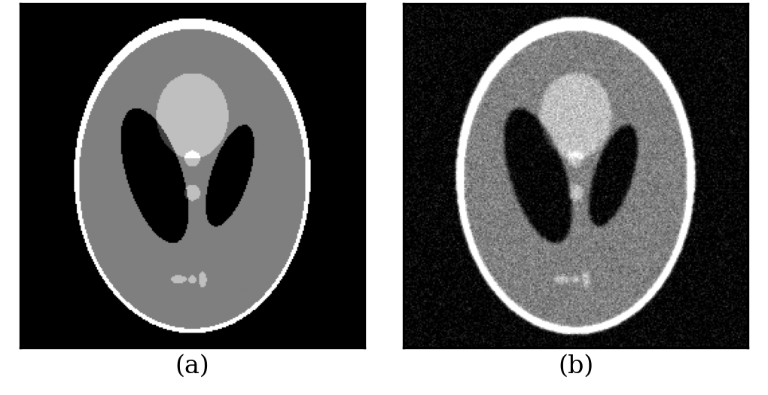
Fig. 1. Example of a column-wide figure. (a) Digital phantom. (b) Reconstructed image. Replace this figure and caption with your own.
Table I
Example of a Table Title
Method | RMSE (a.u.) | SSIM
FBP | x.xx | x.xx
OSEM | x.xx | x.xx
Proposed | x.xx | x.xx

Results
Replace this text with your results. Present quantitative results in figures or tables where possible and describe the main findings clearly.

Discussion
Replace this text with the discussion. Interpret the results, compare them with prior work [3], [4], and state the limitations of the study.

Conclusion
Replace this text with the conclusion. Summarize the main contribution of the work and its impact on medical imaging.
Acknowledgment
Optional. Acknowledge other support here (funding can also be stated in the first-page footnote).
References
- P. Liu et al., “Multi-level wavelet-CNN for image restoration,” in Proc. IEEE Conf. Comput. Vis. Pattern Recognit. Workshops (CVPRW), 2018, pp. 886–895, doi: 10.1109/CVPRW.2018.00121.
- K. Baete et al., “Evaluation of anatomy based reconstruction for partial volume correction in brain FDG-PET,” NeuroImage, vol. 23, no. 1, pp. 305–317, 2004, doi: 10.1016/j.neuroimage.2004.04.041.
- K. Vunckx et al., “Evaluation of three MRI-based anatomical priors for quantitative PET brain imaging,” IEEE Trans. Med. Imag., vol. 31, no. 3, pp. 599–612, 2012, doi: 10.1109/TMI.2011.2173766.
- N. Burgos et al., “Attenuation correction synthesis for hybrid PET-MR scanners: Application to brain studies,” IEEE Trans. Med. Imag., vol. 33, no. 12, pp. 2332–2341, 2014, doi: 10.1109/TMI.2014.2340135.
Please specify DOIs if possible.

 This paragraph of the first footnote may contain support information, including sponsor and financial support acknowledgment. For example, “This work was supported in part by the National Research Foundation under Grant XXXXXXXX.” The next paragraphs should contain the authors’ affiliations, including address and e-mail. For example, F. A. Author and S. B. Author are with the Department of Nuclear Medicine, University of Reconstruction, City, Country (e-mail: first.author@university.edu). T. C. Author is with the Department of Radiology, Recon University, City, Country (e-mail: third.author@recon.edu).
It is recommended that footnotes be avoided (except for the unnumbered footnote with the receipt date on the first page). Instead, try to integrate the footnote information into the text.

